**Name: Neha Antony**

**Roll No:23**

**Batch:MCA -B**

**Date:21-04-2022**

**NETWORKING & SYSTEM ADMINISTRATION LAB**

**Experiment No.: 7**

**Aim**

Familarization of linux commands

**Procedure**

1. **read**

The Linux read command is used to read the contents of a line into a variable.

Syntax

$read variable_name

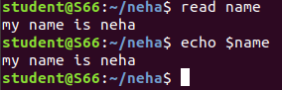

**2. locate**

The locate command and [find](https://www.javatpoint.com/linux-find)command is used to search a file by name. But, the difference between both commands is that locate command is a background process and searches the file in the database whereas, find command searches in the filesystem. The locate command is much faster than find command.

Syntax

$locate filename.txt



**3. locate -i**

It is used to ignore case sensitivity of the specified patterns.

Syntax

$locate -i filename.txt



**4 find**

The find command helps us to find a particular file within a directory. It is used to find the list of files for the various conditions like permission, user ownership, modification, date/time, size, and more.

Syntax

$find filename.txt

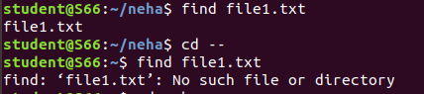

**5.grep**

The 'grep' command stands for **"global regular expression print"**. grep command filters the content of a file which makes our search easy.

Syntax

$grep word filename.txt

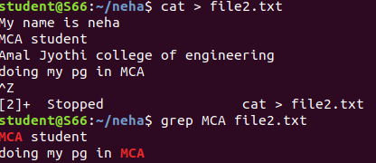

**6. grep -i**

The 'grep -i' command filters output in a case-insensitive way.

Syntax

$grep -i word filename.txt



**7 grep -v**

The 'grep -v' command displays lines not matching to the specified word.

Syntax

$grep -v word filename.txt



**8. grep -A**

grep -A command is used to display the line after the result.

Syntax

$grep -A word file.txt

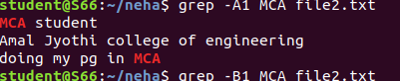

**9. grep -B**

grep -B command is used to display the line before the result.

Syntax

$grep -B word file.txt

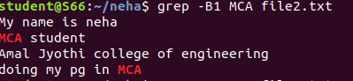

**10.grep -C**

grep -C command is used to display the line after and line before the result.

Syntax

$grep -C word file.txt

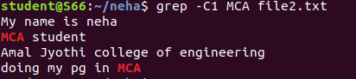

**11. df**

Linux df command is used to display the disk space used in the file system. The 'df' stands for "disk filesystem." It defines the number of blocks used, the number of blocks available, and the directory where the file system is mounted.

Syntax

$du

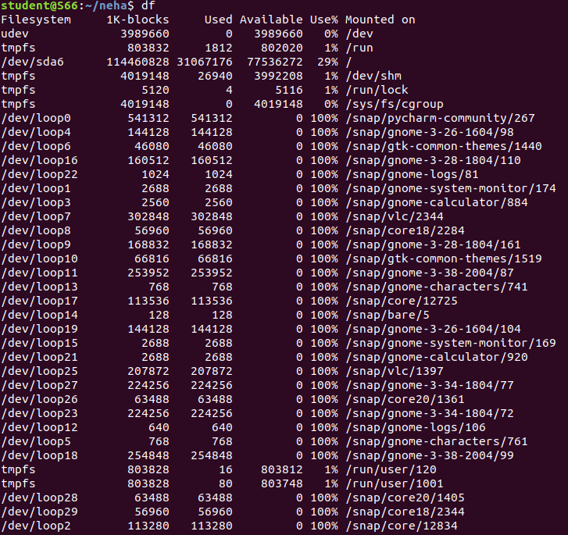

**12. df -m**

it is used to see the report in mega byte

Syntax

$df -m

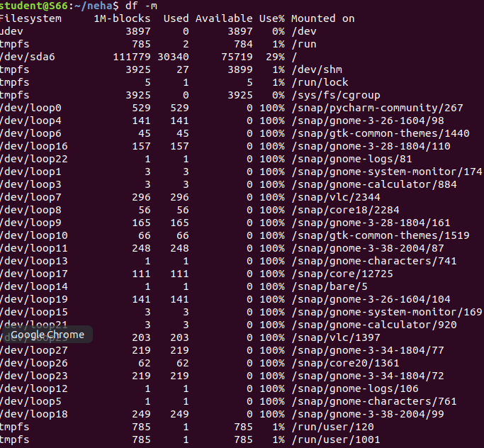

**13. du**

To check how much space a file or directory take.

Syntax

$du



**14.wc**

Linux wc command helps in counting the lines, words, and characters in a file. It displays the number of lines, number of characters, and the number of words in a file. Mostly, it is used with pipes for counting operation.

Syntax

$wc filename.txt



-l, --lines: It is used to print the newline counts.

-w, --words: It is used to print the word counts.

-c, --bytes: It is used to print the byte counts.

-m, --chars: It is used to print the character counts.

